
FOR-LOOP LR Parser
System Programming[ECE3502] — 12th Project Report
Made by: Mohamed Moataz 231010054
Ali Walid 221017810
Abdelrahman Ayman 231007979

Supervised by: Dr. Emad El Samahy
Eng. Rani Youssef

Contents
1.1 Project Overview 6
1.2 Project Objectives 6
1.3 Selected Project Configuration 6
2. System Architecture & Project Structure 7
2.1 High-Level Architecture 7
2.2 Compilation Pipeline 7
2.3 Folder Structure 8
3. Context-Free Grammar (CFG) 10
3.1 What is a Context-Free Grammar? 10
3.2 Top-Level Structure 10
3.3 Statement Types 11
3.4 Expression Precedence Hierarchy 12
3.5 Else Resolution 12
3.6 FIRST and FOLLOW Sets 12
4. Lexical Analysis (Lexer) 13
4.1 Overview 13
4.2 Token Structure 13
4.3 Token Recognition Tables 13
4.4 Scanning Algorithm 14
4.5 Example Tokenization 14
5. Preprocessor 15
5.1 Overview 15
5.2 Supported Directives 15
5.3 Output 15
6. Syntax Analysis (LR(1) Parser) 16
6.1 LR(1) Algorithm Overview 16
6.2 LR(1) Item Sets 16
6.3 Building the ACTION and GOTO Tables 16
6.4 Shift-Reduce Loop 16
6.5 AST Construction (reduce_ast) 16
6.6 LR Trace Output 17
6.7 Smart Syntax Error Reporting 17
7. Semantic Analysis 18
7.1 Overview 18
7.2 Symbol Table 18
7.3 Semantic Checks Performed 18
7.4 Type Inference 19
7.5 Analysis Passes 19
7.6 Symbol Table Output Example 19
8. Optimized Intermediate Code Generation (TAC) 19
8.1 Three-Address Code (TAC) Overview 19
8.2 TAC Instruction Types 20
8.3 TAC Example For Loop 21
8.4 TAC Optimizer 22
9. Code Generation & Object Encoding 23
9.1 Assembly Generation 23
9.2 HTE Object File Encoding 23
10. Runtime Interpreter 24
10.1 Overview 24
10.2 Environment (Scoped Variable Store) 24
10.3 Supported Constructs 24
10.4 Return Semantics 24
11. Graphical Interface (IDE) 25
11.1 Layout 25
11.2 Navigation Panels 25
11.3 Visual Mode and Fullscreen 26
11.4 Tree Rendering 26
12. Input/Output Files 27
12.1 Output Files 27
12.2 Available Test Files 27
12.3 Default Test Program (Input) 28
13. Problems Faced & Possible Improvements 29
13.1 Problems Faced and How They Were Solved 29
13.2 Possible Improvements 31
13.3 Files and Functions 34
14 Testing,Validation, and GUI 38
Correct code 38
Error handling 44
14. Conclusion 45
15. terminologies 46

1. Introduction

1.1 Project Overview
This project is a complete compiler implementation for a significant subset of the C++ programming language. It is bundled with a graphical IDE and visualization tools. The project covers all major phases of compilation as required by the project guidelines ( CFG, Lexer, Syntax, Semantic, Optimized intermediate code generation ), implemented entirely in Python without relying on any external compiler toolkits or parser generators.

The compiler accepts C++ subset source files and processes them through ten sequential stages, from preprocessing to object code. All intermediate file, data structure or representation generated by the compiler are generated as JSON and plain-text files in an output folder, and each is visualized.

The compiler specifically concentrates on the For-loop, it can work with other code subnets to support for loops such as if conditions.

1.2 Project Objectives
- Implement a full LR(1) (bottom-up) parser for a C++ language subset.
- Cover all five required compiler phases: Context-Free Grammar, Lexical Analysis, Syntax Analysis, Semantic Analysis, and Optimized Intermediate Code Generation.
- Provide a complete working IDE for loading, compiling, and visualizing every compilation.
- Support For-loops, arrays, functions, variable declarations, and expressions.

1.3 Selected Project Configuration
Configuration | Selection
Parsing Algorithm | LR(1) (Bottom-Up) Shift/Reduce
Available Statements | For Loop, Functions, Arrays, Variable Declarations, If/Else, I/O (cin/cout)
Implementation Language | Python
GUI Library | Modern themed Tkinter

2. System Architecture & Project Structure

2.1 High-Level Architecture
The project is organized as a Python project hierarchy. Each compiler phase lives in its own folder. The entry point main.py calls each stage in sequence and collects results. The GUI (gui.py) calls run_compiler() and renders artefacts into the corresponding panels.

2.2 Compilation Pipeline
The pipeline is strictly sequential. Each stage receives the output of the previous stage as its input:
Stage | Module | Input | Output
1.Preprocessor | preprocessor.py | source string | Cleaned source + includes list
2. Lexer | lexer.py | Cleaned source string | List of Tokens
3. LR(1) Table Builder | lr1_table.py | grammar.txt | ACTION + GOTO tables
4. LR(1) Parser | parser.py | Tokens + Tables | AST + Parse Tree + LR Trace
5. Semantic Analyzer | semantic.py | AST + includes | Symbol Table
6. TAC Generator | tac.py | AST | Raw TAC list
7. TAC Optimizer | optimizer.py | Raw TAC | Optimized TAC
8. Assembly Generator | asm_gen.py  (code_gen folder ) | Optimized TAC | Assembly
9. Object Encoder | hte.py  (assembler folder) | Assembly text | HTE object file
10. Interpreter | runtime/interpreter.py | AST | stdout + return value

2.3 Folder Structure

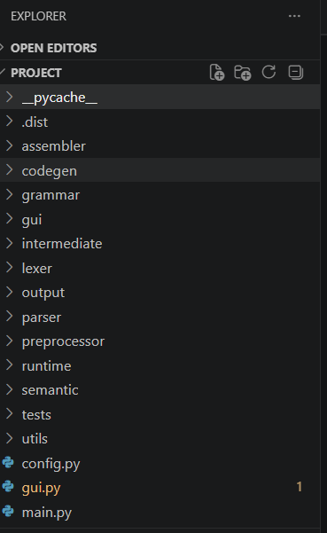

config.py Global paths (BASE_DIRECTORY, OUTPUT_DIRECTORY)
main.py entry-point, Terminal (CLI) control, manage running the compiler
gui.py Full Graphical User Interface
grammar/ CFG, FIRST/FOLLOW, LR(1) item sets, table builder
preprocessor/ Preprocessor class works with # ex. #include
lexer/ Tokens, rules, Lexer class
parser/ LRParser, AST builder, stack
semantic/ SymbolTable, type checker, SemanticAnalyzer
intermediate/ TempFactory, TACGenerator, optimizer
codegen/ tac_to_asm
assembler/ asm_to_hte
runtime/ Environment, Interpreter
gui/ layout, AST/parse renderers
utils/ Error, helpers, input paths, smart error messages
output/ Auto-generated: Folder for outputs(Tokens, intermediate code, etc..)
tests/ Sample input

3. Context-Free Grammar (CFG)

3.1 What is a Context-Free Grammar?
A Context-Free Grammar (CFG) is a formal set of production rules of the form A → B, where A is a non-terminal symbol and B is a (possibly empty) sequence of terminals and non-terminals. Every valid program is a string derivable from the start symbol (Program) by repeatedly replacing non-terminals with their right-hand sides.

3.2 Top-Level Structure
The start symbol is Program, which derives to a list of GlobalItems. A GlobalItem is a using-declaration, a function definition, or a global variable declaration. A FuncDef is a typed function with optional parameters and a block body. A Block is a brace-enclosed sequence of statements.
Non-Terminal | Derives To
Program | One or more GlobalItem entries
GlobalItem | using-declaration | FuncDef | global VarDecl
FuncDef | TYPE ID ( ParamsOpt ) Block
Block | { StmtList }
StmtList | Zero or more Stmt entries

3.3 Statement Types
Statement | Syntax Example
DeclStmt | int x = 5; or int arr[3] = {1,2,3};
ExprStmt | x = y + 1;
IOStmt | cout << expr << endl; or cin >> id; or cin >> arr[i];;
ForStmt | for (init; cond; update) stmt
ReturnStmt | return expr; or return;
Block | { ... }
MatchedStmt | if (cond) matched else matched
UnmatchedStmt | if (cond) stmt (no else, or nested unmatched)

3.4 Expression Precedence Hierarchy
The grammar encodes operator precedence directly through the hierarchy of non-terminals. Each level wraps the next higher-precedence level:
Level | Non-Terminal | Operators
1 (lowest) | AssignExpr | = (right-associative)
2 | OrExpr | ||
3 | AndExpr | &&
4 | EqualityExpr | == !=
5 | RelExpr | < > <= >=
6 | AddExpr | + -
7 | MulExpr | * / %
8 | UnaryExpr | prefix ++ -- ! unary -
9 | PostfixExpr | array subscript [] postfix ++ --
10 (highest) | Primary | literal / identifier / parenthesised expr

3.5 Else Resolution
The classic dangling-else ambiguity is resolved by splitting the Stmt non-terminal into two variants: MatchedStmt (an if-else where the else is always bound) and UnmatchedStmt (an if with no else, or an if-else whose else branch is also unmatched). This approach is conflict-free in LR(1).

3.6 FIRST and FOLLOW Sets
The grammar/first_follow.py module computes two classical sets used by LR parser construction. FIRST(A) is the set of all terminal symbols that can begin a string derived from non-terminal A, including epsilon if A can derive the empty string. FOLLOW(A) is the set of terminals that can appear immediately to the right of A in any sentential form. These sets drive the lookahead computation during LR(1) table construction.

4. Lexical Analysis (Lexer)

4.1 Overview
The lexer reads the preprocessed source string character-by-character and produces a flat list of typed Token objects that the parser will consume. It is implemented entirely by hand in lexer/lexer.py without using any external Lexer generator library.

4.2 Token Structure
A Token is an immutable frozen dataclass with four fields:
Field | Type | Description
token_type | str | Category string: 'ID', 'NUM', 'PLUS', 'IF', 'SEMI', etc…
lexeme | str | The exact source text that matched: 'main', '+', 'if', ';'
line | int | 1-based source line number where the token starts
column | int | 1-based column number where the token starts

4.3 Token Recognition Tables
Three dictionaries in lexer/rules.py drive token recognition:
- KEYWORDS: maps reserved words to their token type: for→FOR, if→IF, else→ELSE, return→RETURN, int/float→TYPE, true/false→BOOL_LIT, cin→CIN, cout→COUT, endl→ENDL, using→USING, namespace→NAMESPACE.
- SINGLE_CHAR_TOKENS: maps single-character punctuation/operators: + → PLUS, - → MINUS, * → MUL, / → DIV, % → MOD, = → ASSIGN, ; → SEMI, , → COMMA, and bracket characters.
- DOUBLE_CHAR_TOKENS: maps two character operators: <= → LE, >= → GE, == → EQ, != → NE, && → AND, || → OR, ++ → INC, -- → DEC, << → LSHIFT, >> → RSHIFT.

4.4 Scanning Algorithm
The Lexer class implements a hand-coded scanner. Its tokenize() method processes the source as follows:
- Whitespace (space, tab, carriage-return) is skipped silently.
- Newlines increment the line counter and reset the column counter.
- // line comments are consumed until end-of-line.
- /* block comments */ are consumed, tracking newlines inside them; an unclosed block comment raises CompilerError.
- A " starts a string literal; escape sequences are preserved. Unterminated strings raise CompilerError.
- A letter or underscore starts an identifier which is looked up in KEYWORDS; if found, a keyword token is emitted, otherwise an ID token.
- A digit starts a number; digits and at most one decimal point are consumed to produce a NUM token.
- Two characters are peeked for DOUBLE_CHAR_TOKENS first, then one character is tried against SINGLE_CHAR_TOKENS.
- After all source is consumed, a synthetic EOF token ('$') is appended.

4.5 Example Tokenization
source line:
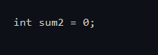
The lexer produces:
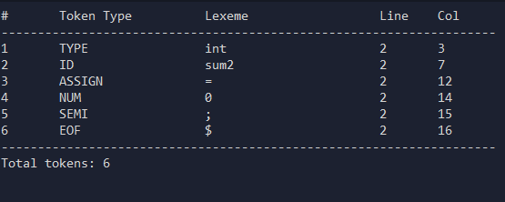

5. Preprocessor

5.1 Overview
The preprocessor runs before the lexer. It scans source lines looking for lines beginning with # and handles them without tokenizing them. All other lines pass through unchanged, preserving line numbers for accurate error reporting.

5.2 Supported Directives
Directive | Behavior
#include <header> | Records the header name in the includes list for semantic validation.
#define NAME value | Stores a macro name→value pair in the macros dictionary.
#undef NAME | Removes a previously defined macro.
#ifdef NAME | Begins a conditional block active only if NAME is defined.
#ifndef NAME | Begins a conditional block active when NAME is NOT defined.
#elif defined(X) | Else-if inside a conditional block.
#else | Else branch of a conditional block.
#endif | Closes the nearest open conditional block.

5.3 Output
The preprocessor returns a PreprocessResult containing: the cleaned output_source string (# lines replaced by blank lines), a list of directives found, a macros dict, and an includes list. The includes list is passed to the semantic analyser to validate that headers like iostream are included before cout/cin are used.

6. Syntax Analysis (LR(1) Parser)

6.1 LR(1) Algorithm Overview
LR(1) stands for Left-to-right scan, Rightmost derivation, with 1 token of lookahead. It is the most powerful single-token-lookahead shift-reduce parsing algorithm. The parser maintains three parallel stacks. A State stack, an AST stack, and a parse-tree stack, and consults two tables to decide every action.

6.2 LR(1) Item Sets
An LR(1) item is a 4-tuple (lhs, rhs, dot_position, lookahead). The dot marks how far the parser has progressed through a production.
The grammar/lr1_items.py module implements closure(items), which expands an item set by adding all items reachable via epsilon transitions, and goto(items, symbol), which computes the next state after reading one symbol. Together they drive the collection of LR(1) item sets.

6.3 Building the ACTION and GOTO Tables
The grammar/lr1_table.py module runs BFS(Breadth-First search: visit all possible nodes) over all item sets to enumerate approximately 200+ parser states. For each state:
- SHIFT: when the dot is before a terminal, add a shift action to the ACTION table.
- REDUCE: when the dot is at the end of a production, add a reduce action on each lookahead terminal.
- ACCEPT: when the start production is complete and the lookahead is EOF.
- GOTO: after a reduce, the non-terminal is used to index the GOTO table for the next state.
Any shift/reduce(Can mean Ambiguity) or reduce/reduce(means a critical flaw) conflict raises CompilerError immediately, confirming the grammar is conflict-free.

6.4 Shift-Reduce Loop
The LRParser.parse_with_trace() method implements the core loop

6.5 AST Construction (reduce_ast)
When the parser performs a reduce action, it calls reduce_ast(lhs, rhs, children). This function in parser/ast_builder.py contains over 100 pattern-match cases that convert each production rule plus its children into a structured AST node dictionary. Structural non-terminals (used only to encode precedence) are transparent. They return their child's value directly.

6.6 LR Trace Output
Every step is recorded in lr_trace: a list of dicts containing the step number, state stack snapshot, current lookahead, and the action taken (SHIFT/REDUCE/ACCEPT). This trace is displayed in the LR Trace panel of the GUI with color-coded rows (blue for shift, amber for reduce, and green for accept).

6.7 Smart Syntax Error Reporting
When the parser has no action for a (state, lookahead) pair, the utils/smart_syntax_error.py module inspects the ACTION table for the current state to find which tokens would have been valid. It produces a human-friendly message with expected solutions. The GUI additionally passes every error through a categorization function that identifies the error type (syntax, type mismatch, undeclared variable, redeclaration, division by zero, missing return, cin input exhausted, file not found) and prepends a plain-English explanation with a specific fix tip, so a beginner can understand what went wrong.

7. Semantic Analysis

7.1 Overview
After the parser produces a valid AST, the semantic analyser walks it to enforce language rules that the CFG cannot express (variable scoping, type checking, required header validation, and duplicate declaration detection). The semantic analyser fulfills all four project requirements for this phase.

7.2 Symbol Table
The SymbolTable (symbol_table.py) implements a scoped symbol table using a list of dictionaries one dict per scope level, with level 0 being the global scope and increments for each inner level.

Operation | Behavior
enter_scope() | Pushes a new empty scope dictionary onto the scope stack.
exit_scope() | Pops the innermost scope, discarding its symbols.
declare(name, type, ...) | Adds a symbol to the current scope, raises CompilerError on duplicate declarations.
lookup(name) | Searches from innermost to outermost scope, raises CompilerError if not found.
all_symbols() | Flattens all scopes into a single list for JSON serialization.

Each symbol record stores(name, type, scope_level, is_param, init_value, is_array, and array_size)

7.3 Semantic Checks Performed
- Check that all used variables are declared (lookup raises error on missing symbols).
- Check for no repeated variable declarations in the same scope (declare raises error on duplicate).
- Check that all variables are type-compatible in expressions (inferexpr_ty_pe promotes int+float → float, validates assignments).
Check that cout, cin, and endl are available via #include <iostream> and using namespace std.

7.4 Type Inference
The type_checker.py module provides infer_expr_type(), a recursive function that walks an expression AST node and returns a Python string ('int', 'float', 'bool', 'string', etc.). It handles BinOp, UnaryOp, Identifier lookups, literals, and array subscripts.

7.5 Analysis Passes
The SemanticAnalyzer performs two passes over the AST:
- Pass 1: Scan global items to detect “using namespace std' . This enables std identifiers without a header check.
- Pass 2: Walk every function, block, declaration, expression, and I/O statement. For each node it enters/exits scopes, declares symbols, verifies identifiers are declared before use, and checks expression types.

7.6 Symbol Table Output Example
The symbol table is serialized to output/symbol_table.json and displayed in the Symbol Table panel:
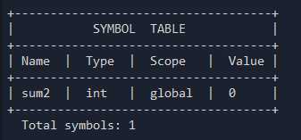

8. Optimized Intermediate Code Generation (TAC)

8.1 Three-Address Code (TAC) Overview
The intermediate representation used by is Three-Address Code (TAC). Each TAC instruction has at most three operands and one operator, making it easy to optimize and translate to assembly. TAC is a flat sequence of simple assignments, arithmetic, labels, and jumps.

8.2 TAC Instruction Types
Instruction Pattern | Meaning
func name: | Marks the start of a function.
endfunc | Marks the end of a function.
_t1 = a + b | Binary arithmetic/relational expression
x = _t1 | Copy (MOV), assigns expression result to a named variable.
_t2 = i < 3 | Relational comparison, result is boolean (0 or 1).
ifFalse _t2 goto LABEL | Conditional branch, used for if/for control flow.
goto LABEL | Unconditional jump.
LABEL: | Branch target label, e.g. FOR_START_1:
return val | Returns a value from a function.
print x | Pseudo-instruction for cout output.
read x | Pseudo-instruction for cin input.

8.3 TAC Example For Loop
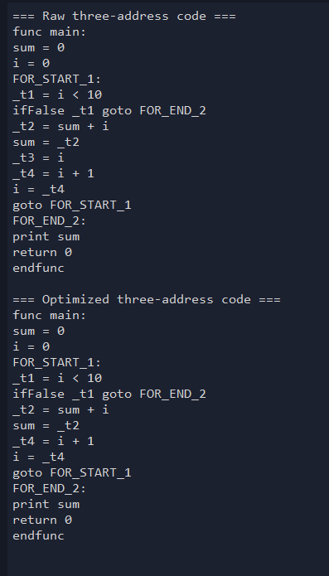

8.4 TAC Optimizer
The optimizer in intermediate/optimizer.py runs up to 10 passes of four optimizations in sequence. Passes repeat until no change occurs (fixed-point iteration).

Optimization | Function | What It Does
Constant Folding | _fold_and_simplify() | Evaluates expressions with known numeric operands at compile time. _t1 = 2 + 3 becomes _t1 = 5. Also simplifies x = x + 0, x * 1, x * 0.
Copy Propagation | _propagate_copies() | When a copy x = y exists, replaces later uses of x with y if x is not reassigned. Reduces the number of temporaries.
Common Subexpression Elimination (CSE) | _eliminate_common_subexpressions() | If the same computation a op b appears twice with no intervening assignments to a or b, the second occurrence is replaced by the result of the first.
Dead Code Elimination | _remove_dead_assignments() | Removes assignments to temporaries (_t*) that are never subsequently read.

Structural lines, labels, gotos, ifFalse, func/endfunc, print, read, return are never removed by the optimizer. Only assignment lines targeting temporaries are candidates for elimination.

9. Code Generation & Object Encoding

9.1 Assembly Generation
The codegen/asm_gen.py module translates each optimized TAC line to a single assembly mnemonic. The mapping is straightforward pattern matching:

TAC Instruction | Assembly Mnemonic
func name: / endfunc | FUNC name / ENDFUNC
label: | LABEL label
goto L | GOTO L
ifFalse c goto L | IF_FALSE c, GOTO L
return val | RET val
x = y | MOV x, y
x = a + b | ADD x, a, b
x = a - b | SUB x, a, b
x = a * b | MUL x, a, b
x = a / b | DIV x, a, b
x = a < b | LT x, a, b
x = a == b | EQ x, a, b

9.2 HTE Object File Encoding
The assembler/hte.py module encodes the assembly text into a HTE object file: a simplified format inspired by Intel HEX / Motorola S-record formats. The format uses three record types:
- H record: Header: program name (6 chars), start address (hex), total byte length.
- T records: Text: address, byte count, and hex-encoded payload (up to 30 bytes per record).
- E record: End: start address for the execution entry point.

10. Runtime Interpreter

10.1 Overview
The project includes a complete tree-walking interpreter so programs can actually be executed and their output displayed in the GUI. The interpreter works directly on the AST. It does not use the TAC or assembly, enabling immediate feedback during development.

10.2 Environment (Scoped Variable Store)
The Environment class holds a stack of scope dictionaries. push()/pop() manage function and block scopes. declare() adds a variable to the current scope and raises CompilerError on duplicate. assign() walks scopes outward to find an existing binding. get() similarly reads from the nearest enclosing scope.

10.3 Supported Constructs
The interpreter supports all constructs produced by the compiler:
Construct | Implementation
Arithmetic/logical/relational expressions | Recursive eval_expr() with all BinOp and UnaryOp cases.
Variable declarations and assignments | Including array declarations with initializers.
If / if-else | Evaluated by testing condition then executing the appropriate branch.
For loops | Handles initialization, conditions, updates, and body in the standard C++ for-loop order.
Function calls | Argument passing and local scope isolation via Environment.
cout | cout streams each output chunk live to the terminal as the program runs.
Array subscript read/write | Stored as Python lists in the Environment.

10.4 Return Semantics
Return semantics are implemented using a Python exception (ReturnSignal). When a return statement is hit anywhere inside nested blocks, the signal propagates up the call stack and is caught by _call_function(). This cleanly handles early returns from nested loops or blocks.

11. Graphical Interface (IDE)

11.1 Layout
The GUI is a single-window application built with CustomTkinter. It is divided into three areas: a sidebar with navigation buttons, a top bar with the panel title, sample-file dropdown, a Compile button, and a Run button that compiles and executes in one click, and a content area where only one panel is visible at a time.

11.2 Navigation Panels
Panel | Content
Editor | Source code editor with file browser, load, save-report, and Run buttons. Pre-loaded with the default test file.
Grammar (CFG) | Opens the CFG viewer in a separate window showing all grammar productions in a scrollable text widget.
Summary | Post-compilation summary: token count, function/declaration counts, TAC lines, output directory.
Tokens | Formatted table of all tokens with type, lexeme, line, and column.
AST | Abstract Syntax Tree in JSON or interactive pan/zoom visual tree canvas.
Parse Tree | Concrete parse tree in JSON or visual tree canvas.
LR Trace | Step-by-step LR parser trace in text or animated table
Symbol Table | Table of all symbols with name, type, scope, and initial value.
TAC | Raw TAC and Optimized TAC displayed side-by-side.
Assembly | Assembly mnemonics (MOV, ADD, FUNC, RET, …) from tac_to_asm().
Object Code | HTE object file bytes (H/T/E records).
Program Output | Interactive terminal that streams cout output live. When the program reaches a cin statement it pauses and activates an input bar at the bottom of the terminal where the user types the value and presses Enter. Displays exit code on completion

11.3 Visual Mode and Fullscreen
The AST, Parse Tree, and LR Trace panels have a Text / Visual segmented button. Visual mode renders on a Tkinter Canvas. Every result panel has a Fullscreen button that opens a maximized window at full screen, re-rendering the same content at the larger size.

11.4 Tree Rendering
The gui/ sub-package handles tree and trace rendering (gui/tree_layout.py) that assigns (x,y) coordinates to each node producing a compact, non-overlapping layout. Nodes are drawn as rounded rectangles connected by lines on a Tkinter Canvas (gui/tree_canvas.py).

12. Input/Output Files

12.1 Output Files
File | Contents
output/tokens.json | List of all tokens (type, lexeme, line, column).
output/ast.json | Complete Abstract Syntax Tree as nested JSON.
output/parse_tree.json | Concrete parse tree with all grammar symbols.
output/lr_trace.json | Step-by-step list of every shift/reduce/accept action.
output/symbol_table.json | All declared symbols with type, scope, and initial value.
output/preprocessor.json | Directives, macros, and includes resolved.
output/run_result.json | Program stdout, return value, and global state after execution.
output/tac.txt | Optimized TAC, one instruction per line.
output/program.asm | Assembly mnemonics, one per line.
output/program.obj | HTE object file with H/T/E records.

12.2 Available Test Files
tests/test1.txt
tests/test2.txt
tests/test_for_loop.txt
tests/test_cpp.txt
tests/sample.cpp

12.3 Default Test Program (Input)
The default test program is a built-in IDE that serves as the primary interface for manual C++ code entry and compilation testing.
The recommended already made input file to run is tests\test_for_loop.txt It exercises the widest range of compiler features:
- Function definition with parameters (add function).
- Integer, float, and array variable declarations with initializers.
- A for loop iterating over the array.
- Arithmetic expressions and assignments inside the loop.
- cout output and return statement.

13. Problems Faced & Possible Improvements
This section documents every significant problem encountered during development, the exact code location where it was resolved, and ideas for future improvement of the compiler and IDE.

13.1 Problems Faced and How They Were Solved
The table below covers all 12 concrete bugs and design issues that arose during implementation, the exact files and functions involved, and the fix applied.

# | Problem | How It Was Solved in Code | Possible Improvement
1 | cout and cin compiled without #include <iostream> in the source file. | File: semantic/semantic.py  Function: _check_std_identifier()  A dictionary _STD_IDENTIFIERS maps cout/cin/endl to "iostream". On every use, the semantic analyzer checks whether that header is in the preprocessor includes list. Missing header → CompilerError. | Extend the dictionary to cover <cmath>, <string>, <vector>, etc., enabling enforcement of sqrt(), string, and vector header requirements.
2 | std::cout and std::cin were rejected with a parse error even though the grammar appeared to support them. | File: grammar/grammar.txt — Added IOStmt productions for ID SCOPE COUT/CIN.  File: lexer/rules.py — Mapped "::" → SCOPE.  File: parser/ast_builder.py — Added (ID, SCOPE, COUT/CIN) cases and qualified=True flag. Semantic analyzer skips namespace check when qualified=True. | Extend to std::endl, std::string, std::vector and other qualified identifiers.
3 | Arrays declared without a size or initializer (int arr[];) were accepted silently, causing runtime crashes on access. | File: semantic/semantic.py  Function: _handle_stmt(), DeclStmt branch — Raises CompilerError when array_size is None and no initializer list is present.  File: runtime/interpreter.py  Function: _default_value() — Defaults to an empty list as a safe fallback. | Add runtime bounds-checking on every array subscript, replacing generic Python IndexError with a proper CompilerError naming the array, index, and declared size.
4 | cin >> arr[i] caused a syntax error; only simple variable names were accepted as cin targets. | File: grammar/grammar.txt — New CinTarget rule: CinTarget → ID LBRACKET Expr RBRACKET | ID.  File: parser/ast_builder.py — Added CinTargetIndex and CinTargetVar nodes.  File: runtime/interpreter.py — Dispatcher routes on target node type.  Also updated: semantic/semantic.py and intermediate/tac.py to read name from the dict target. | Extend cin targets to pointer dereferences (*ptr) and struct member access (obj.field). Add a semantic check verifying the index is integer-typed.
5 | Adding if/else produced a shift-reduce conflict in the LR(1) table. | File: grammar/grammar.txt — Stmt split into MatchedStmt (if with bound else) and UnmatchedStmt (if without else or nested unmatched). This encoding is conflict-free in LR(1).  File: grammar/lr1_table.py — Table builds without conflict after the split. | -
6 | A return inside a deeply nested for loop did not exit the function immediately; execution continued after the loop. | File: runtime/interpreter.py  Class: ReturnSignal (top of file).  Exception subclass carrying the return value.  Function: _call_function() — Wraps body execution in try/except ReturnSignal. Python exception propagation unwinds all nested loops automatically. | Replace exception-based returns with a return_value field and an early-exit flag on the interpreter.
7 | The TAC optimizer entered an infinite loop: constant-folding and copy-propagation kept undoing each other. | File: intermediate/optimizer.py  Function: optimize_tac()  Added a fixed upper bound of 10 passes. If output equals input, the loop terminates early via fixed-point check. | Compute def-use chains before optimizing and apply each pass in a single data-flow sweep. This guarantees convergence in one pass and eliminates the need for a fixed-point loop.
8 | Logical && and || evaluated both operands even when the result was already determined, causing runtime errors | File: runtime/interpreter.py  Function: _eval_expr(), BinOp branch — Both sides are currently evaluated before _eval_binop() is called. This remains an open issue. | Move logical operator checks into _eval_expr() before evaluating the right operand. Evaluate the right side only when needed, matching standard C++ short-circuit semantics.
9 | Division by literal zero (int x = 5 / 0;) was not detected until runtime, producing a cryptic Python traceback. | File: intermediate/optimizer.py  Function: _fold_and_simplify() — During constant folding, checks whether the right operand is zero before attempting the fold. Raises CompilerError 'division by zero detected in constant expression'.  File: runtime/interpreter.py  Function: _eval_binop(): For non-constant divisors, a runtime guard raises CompilerError instead of propagating the Python exception. | Extend the check to modulo-by-zero (%).

13.2 Possible Improvements
The following table lists features and enhancements that could extend the compiler and IDE beyond their current scope. Items are ordered from most foundational to most advanced.

Feature to Add | Why It Is Useful | How to Implement
while and do-while loops | while and do-while are common patterns absent from the current grammar, limiting which programs can be tested. In addition the while loop it self is so close to the for loop in logic which will possibly make it easy to implement. | Add WhileStmt and DoWhileStmt grammar productions. Add AST nodes in ast_builder.py. Add interpreter cases that evaluate condition before (while) or after (do-while) executing the body.
break and continue inside loops | No way to exit a loop early or skip an iteration limits the programs that can be run. | Introduce BreakSignal and ContinueSignal exception classes similar to ReturnSignal. Raise BreakSignal on break (caught in the for-loop handler) and ContinueSignal to skip to the update step.
String variables (std::string) | String literals appear in cout but cannot be stored in a variable; string s = "hello"; fails. | Add STRING as a type keyword in the lexer and grammar. Treat it like int/float in the semantic analyzer. In the interpreter return an empty Python string for string type and handle + as concatenation in _eval_binop().
Struct / class support | Only primitive types and arrays are supported; struct declarations are a natural next step. | Add a StructDef grammar rule and AST node. Track struct types in a struct_types dictionary in the semantic analyzer. Represent struct instances as Python dicts in the interpreter. Add member access (obj.field) as a new PostfixExpr production.
Function overloading | Two functions with the same name but different parameter types raise a redeclaration error, which is incorrect C++ behavior. | Key the functions dictionary on (name, parameter_types) tuples.  The semantic analyzer resolves the correct overload at each call site based on argument types.
Pointer and reference types | No concept of pointers or references exists, making pass-by-reference function arguments impossible. | Add STAR and AMP tokens. Extend DeclStmt to allow pointer declarators (int* p). Add UnaryOp cases for &x (address-of) and *p (dereference). Represent pointers as name references in the interpreter.
Switch-case statement | switch/case is absent from the grammar; programs must be rewritten as if/else chains. | Add SwitchStmt to the grammar with CaseClause and DefaultClause children. In the interpreter evaluate the switch expression once, then compare with case labels using ==. Use a SwitchBreakSignal to exit the switch block.
Persistent IDE settings and theme support | The IDE always opens in the same default state; users cannot save preferences between sessions. | Write config.json on exit (font_size, theme, last_file). Read it on startup and apply settings. Add a light/dark toggle to the top bar that switches the CustomTkinter appearance mode and saves the preference.
Incremental / background compilation | Every compile blocks the GUI; there is no inline feedback while typing. | Run the lexer and parser in a background thread (threading.Thread). Post results via a queue and tkinter.after(). Highlight syntax errors inline using text tags.
Export to standard assembly (x86 / ARM) | Current assembly uses custom mnemonics that cannot be assembled by any real toolchain. | Replace asm_gen.py with a backend emitting NASM-compatible x86-64 or ARM Thumb-2. Map TAC temporaries to virtual registers and implement a simple register allocator (linear scan). This allows output to be assembled and run natively.

13.3 Files and Functions
Below is a snippet of some files and functions code for quick reference.
semantic/semantic.py:
check_std_identifier:
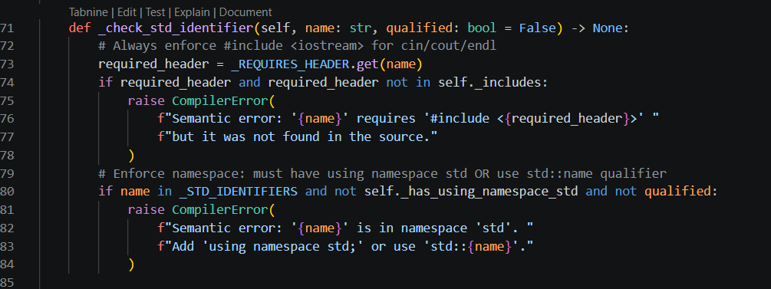

handle_stmt:
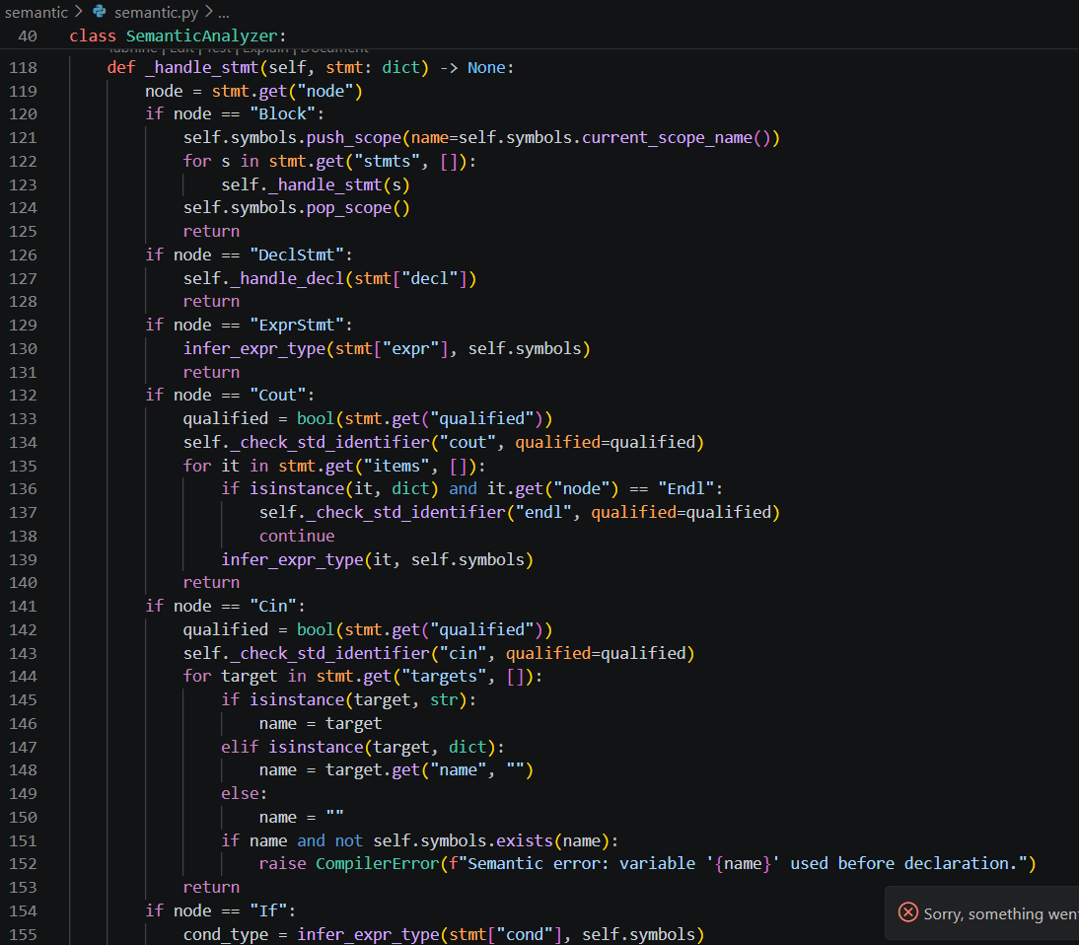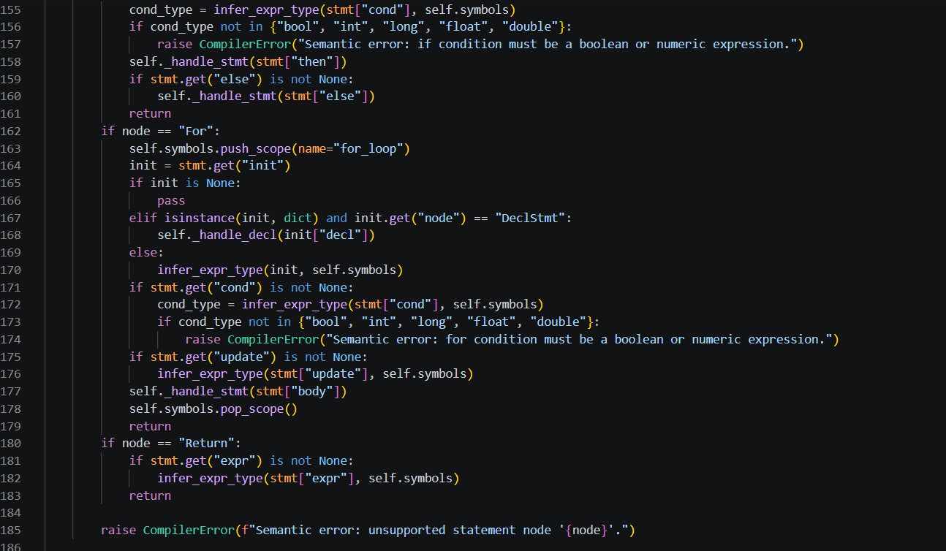

grammar/grammar.txt:
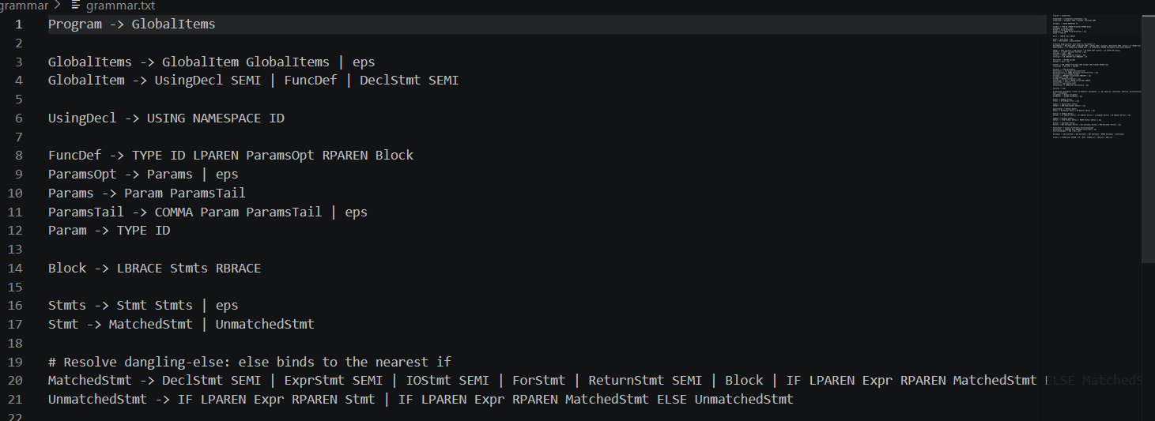
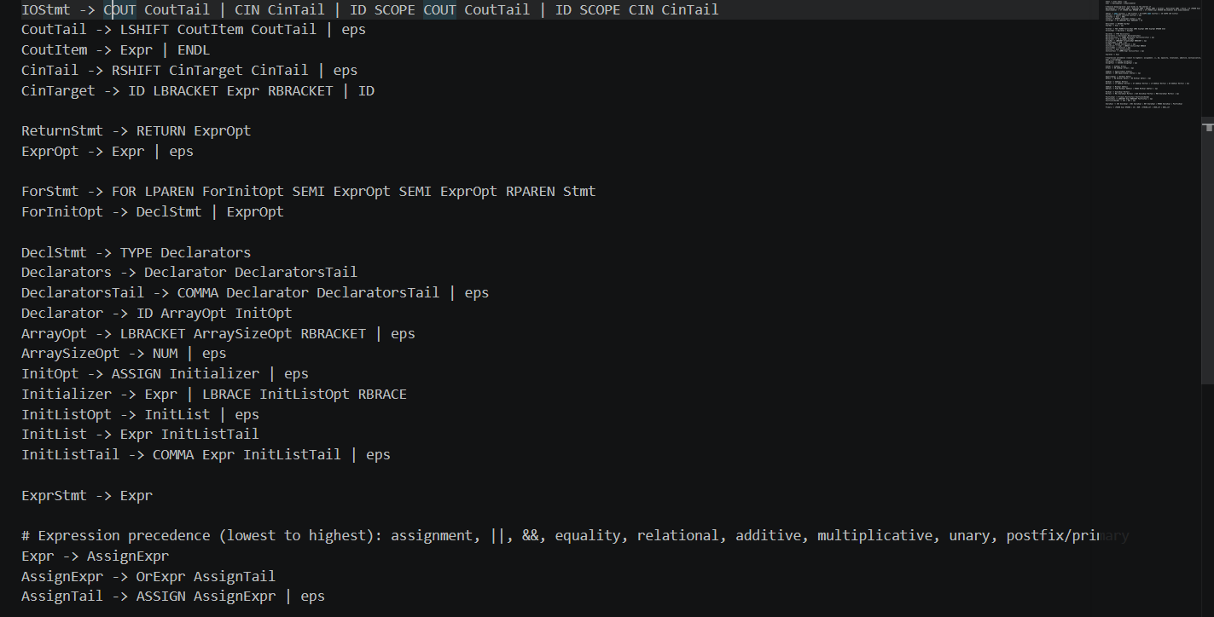
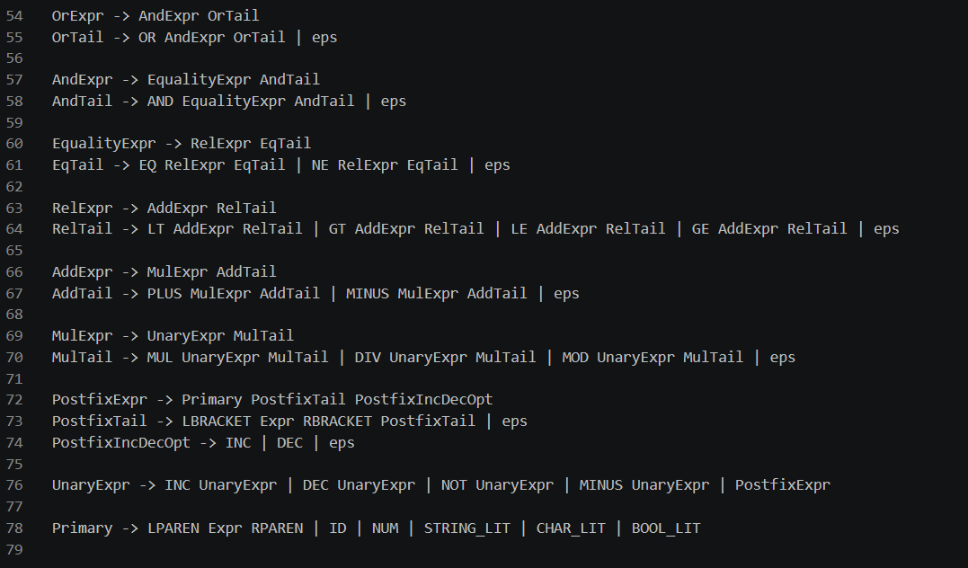

runtime/interpreter.py:
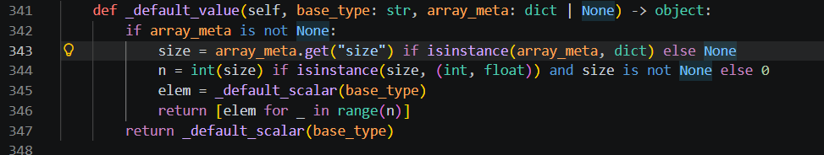

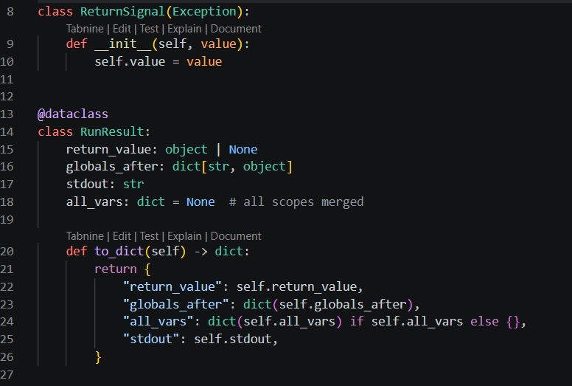
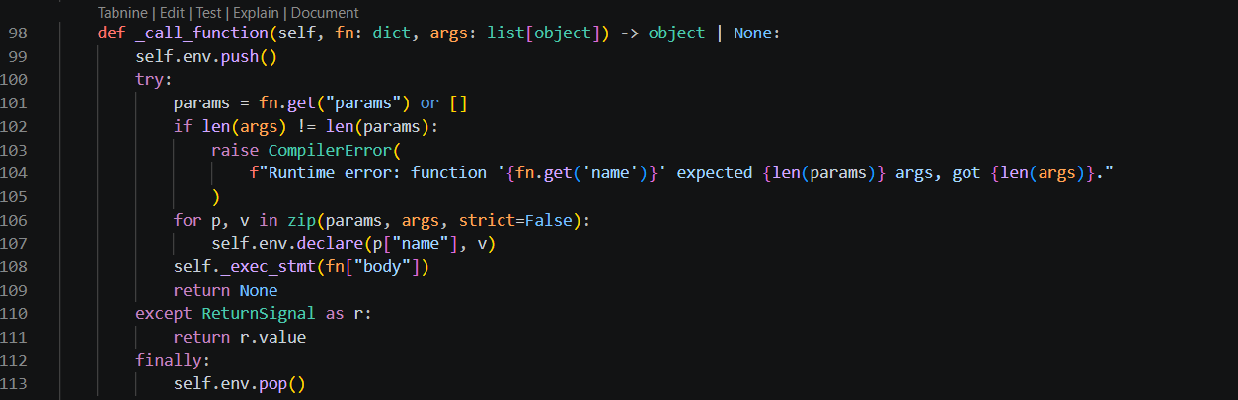

14 Testing,Validation, and GUI

Correct code
Here there is a simple code input with its output folder to verify compiler is working and to show the GUI.
Input/Output:
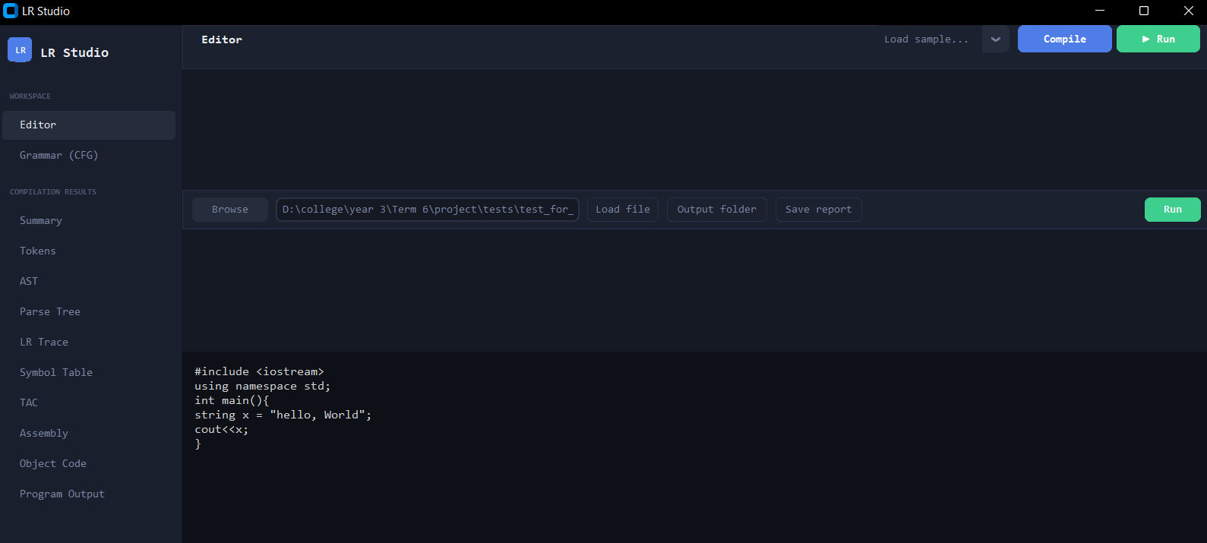
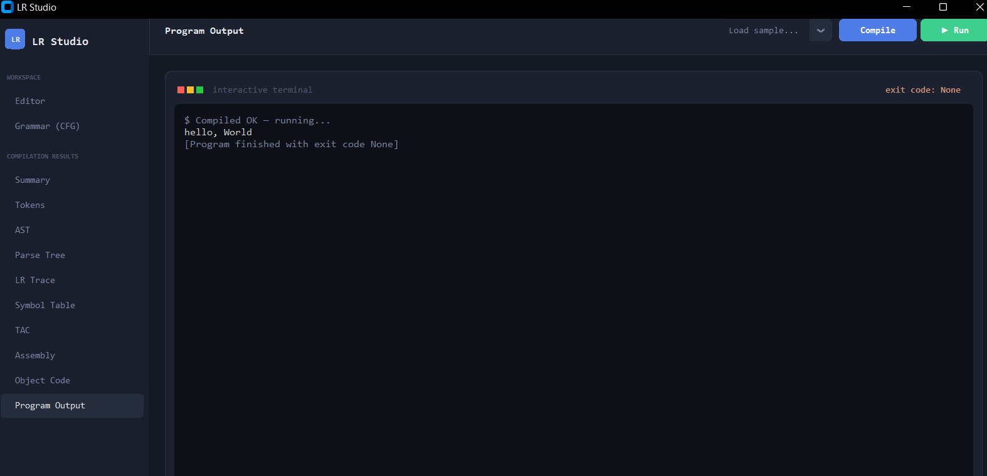

Summary:
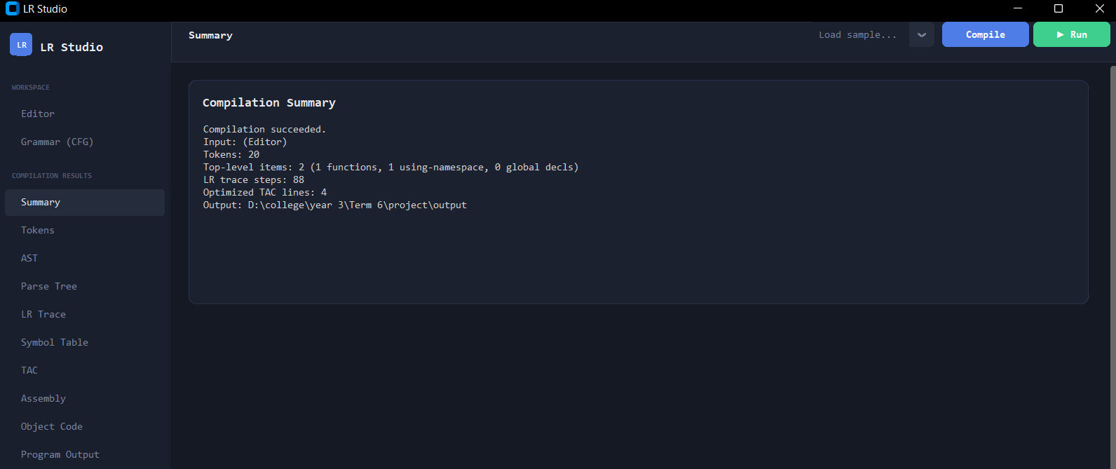
Tokens: 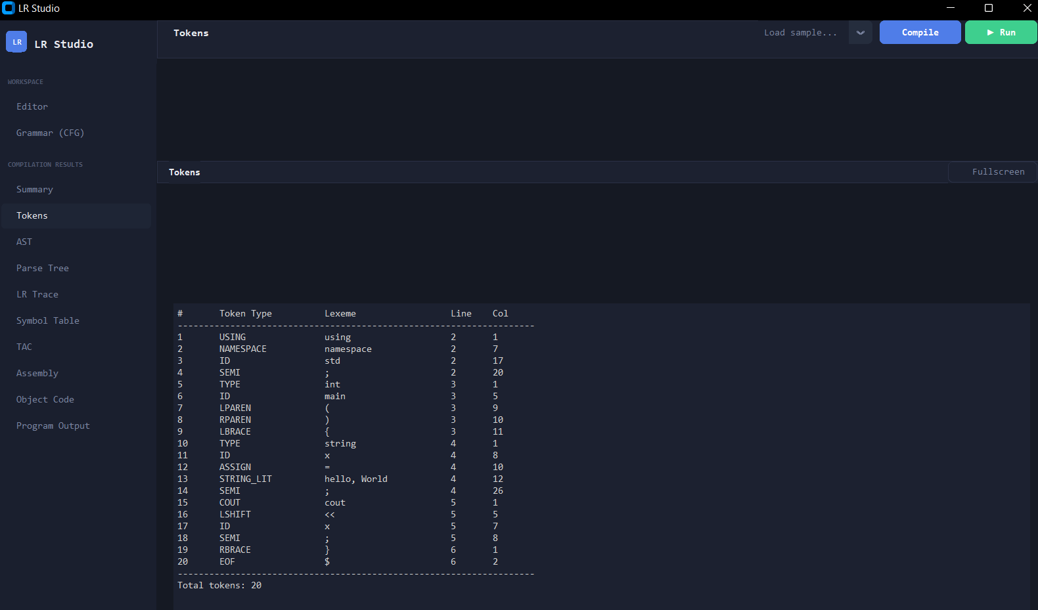
AST: 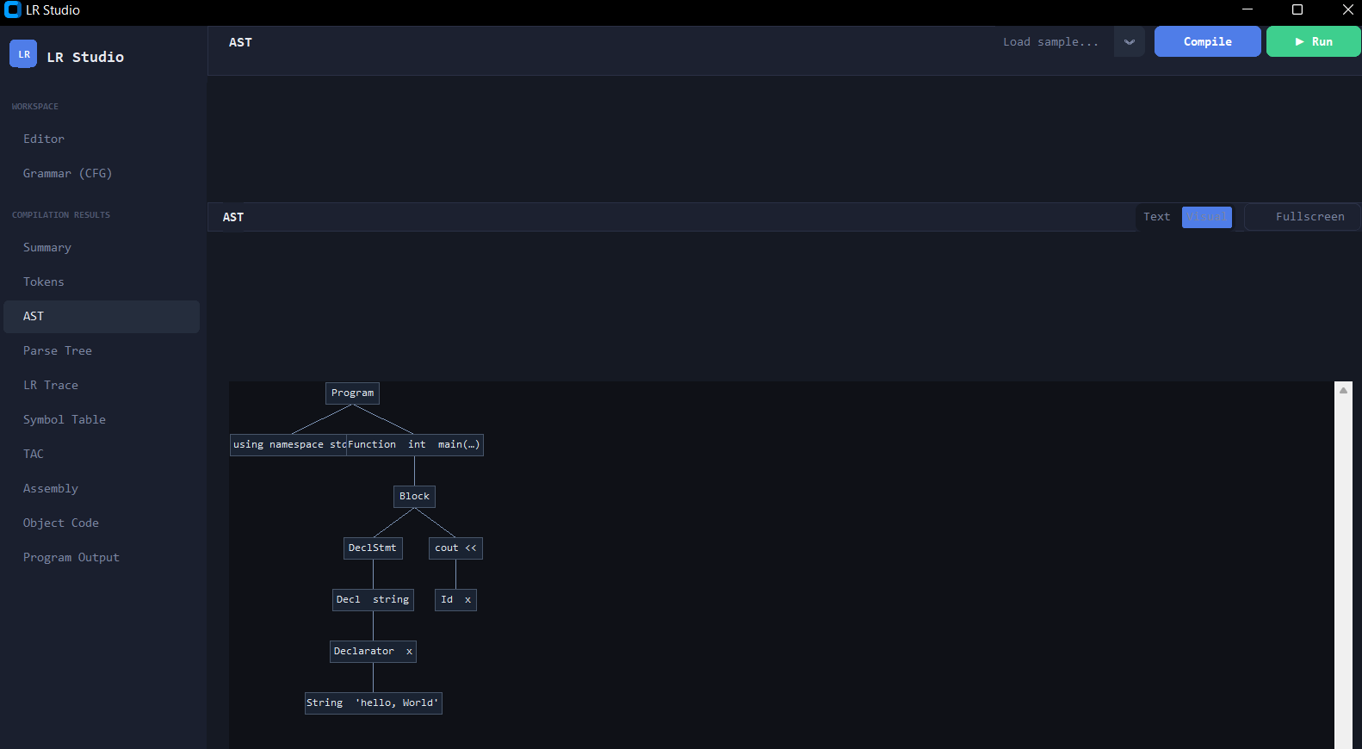

Part of the parse tree:
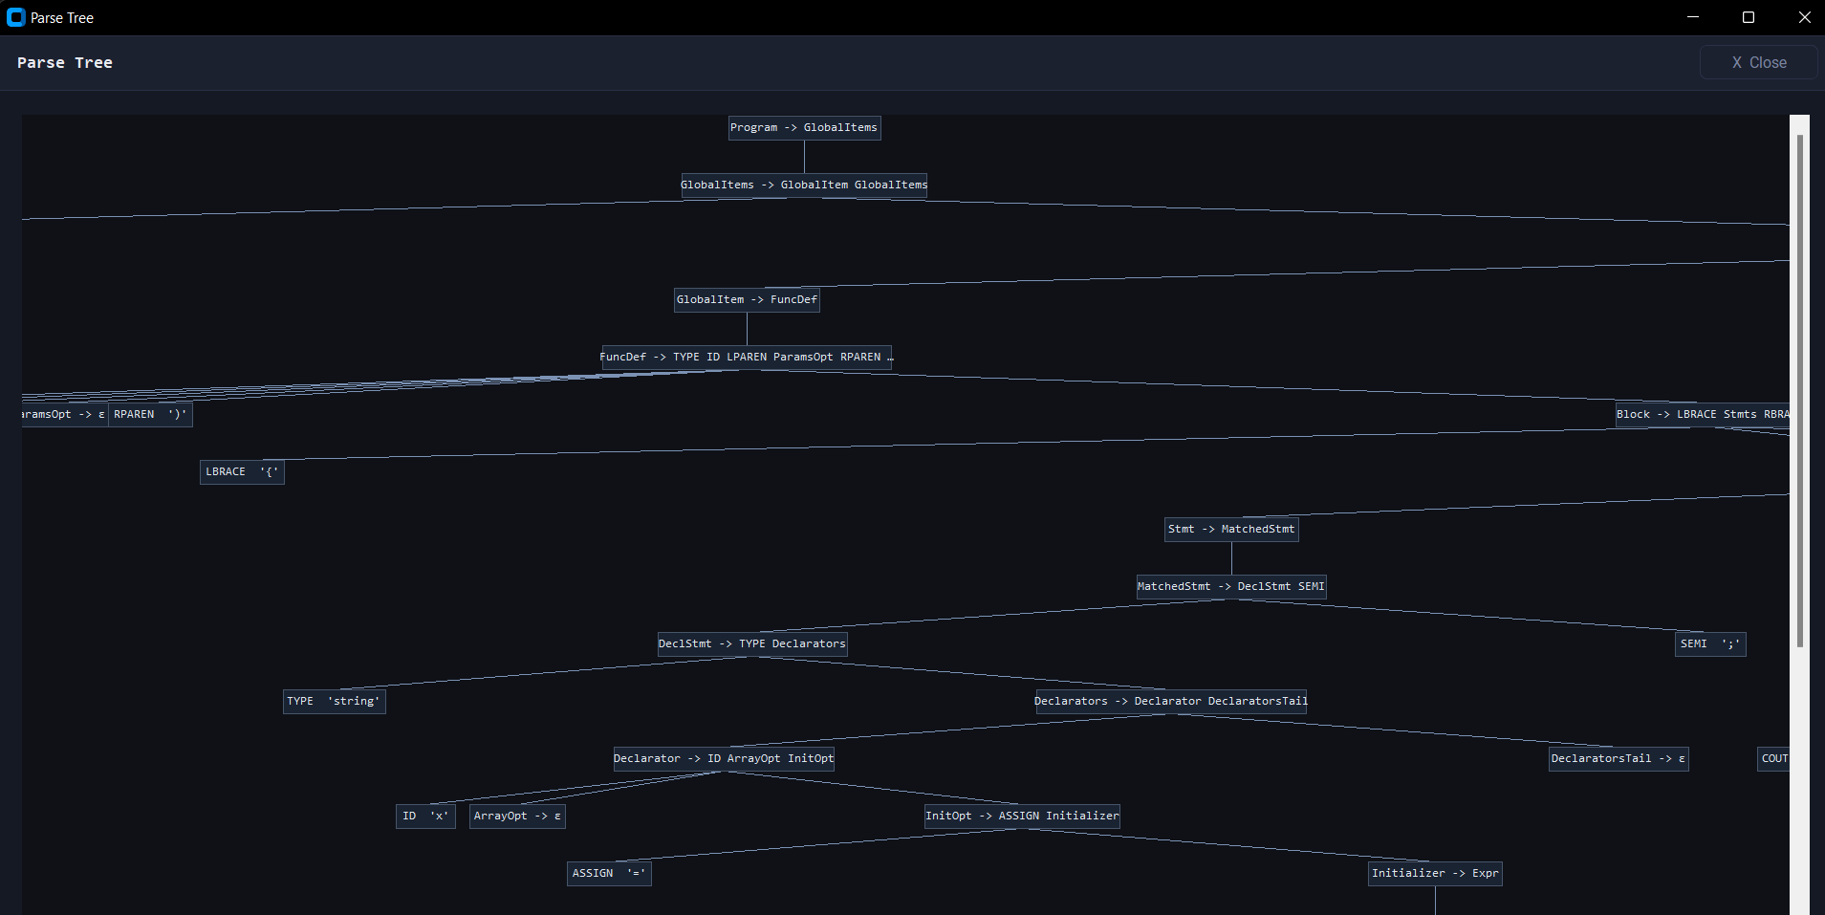

LR trace:
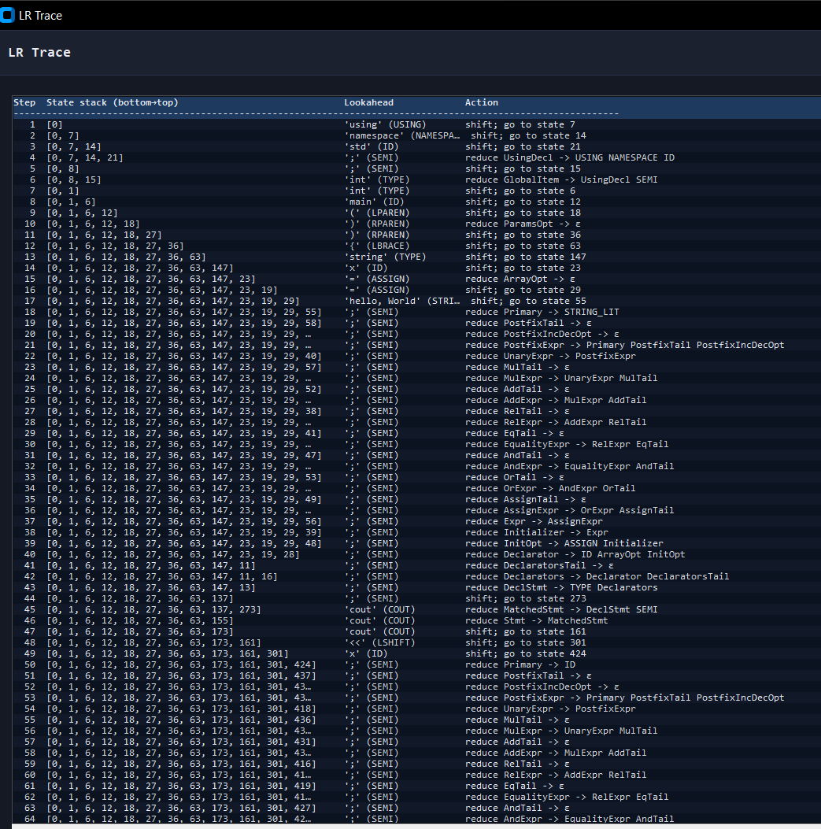
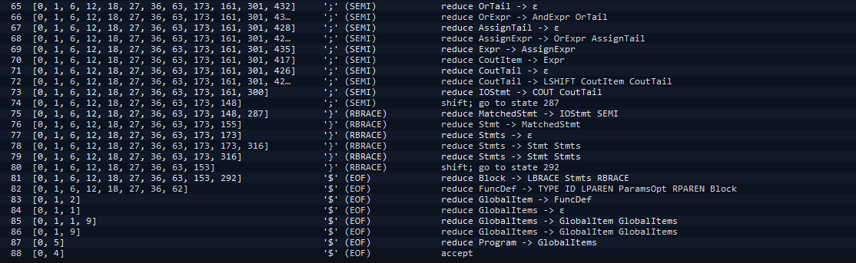

Symbol table:
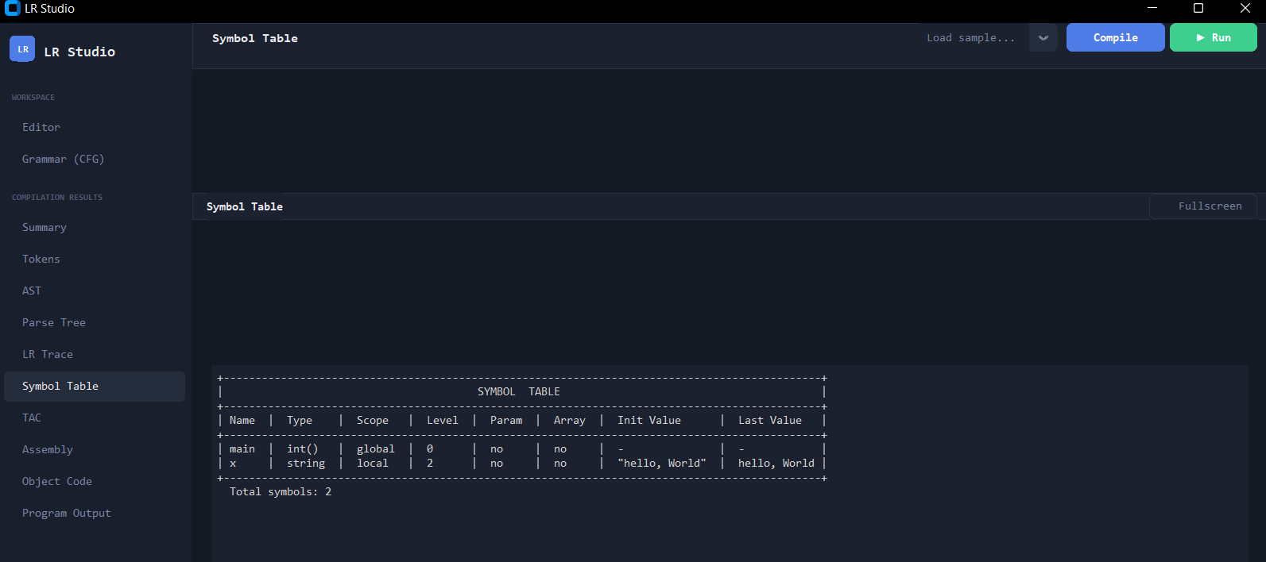
TAC:
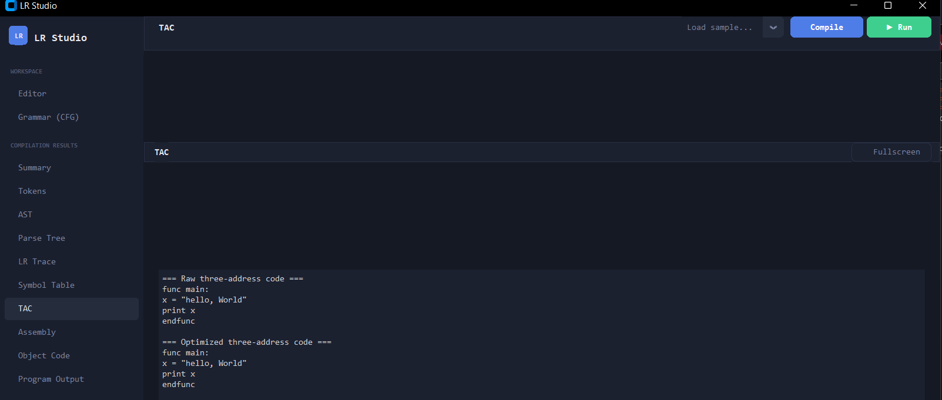
Assembly:
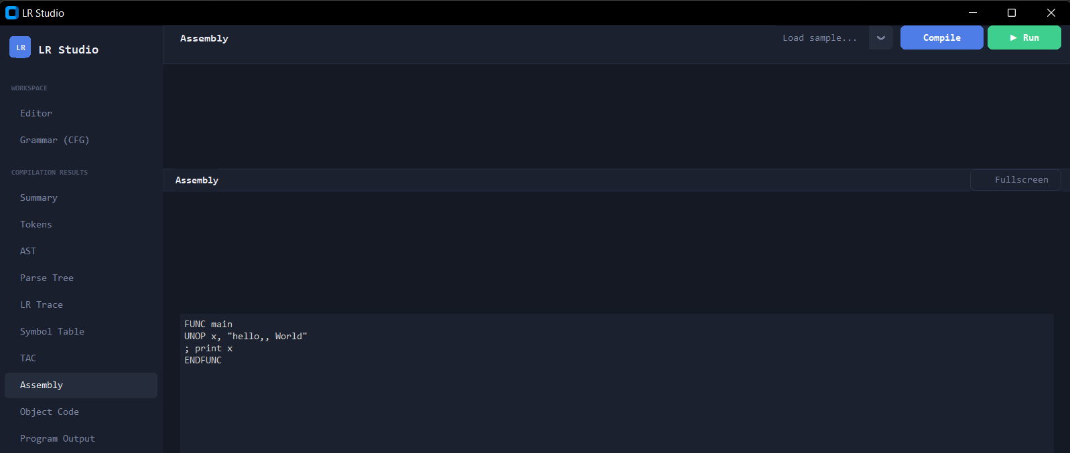

Object code:
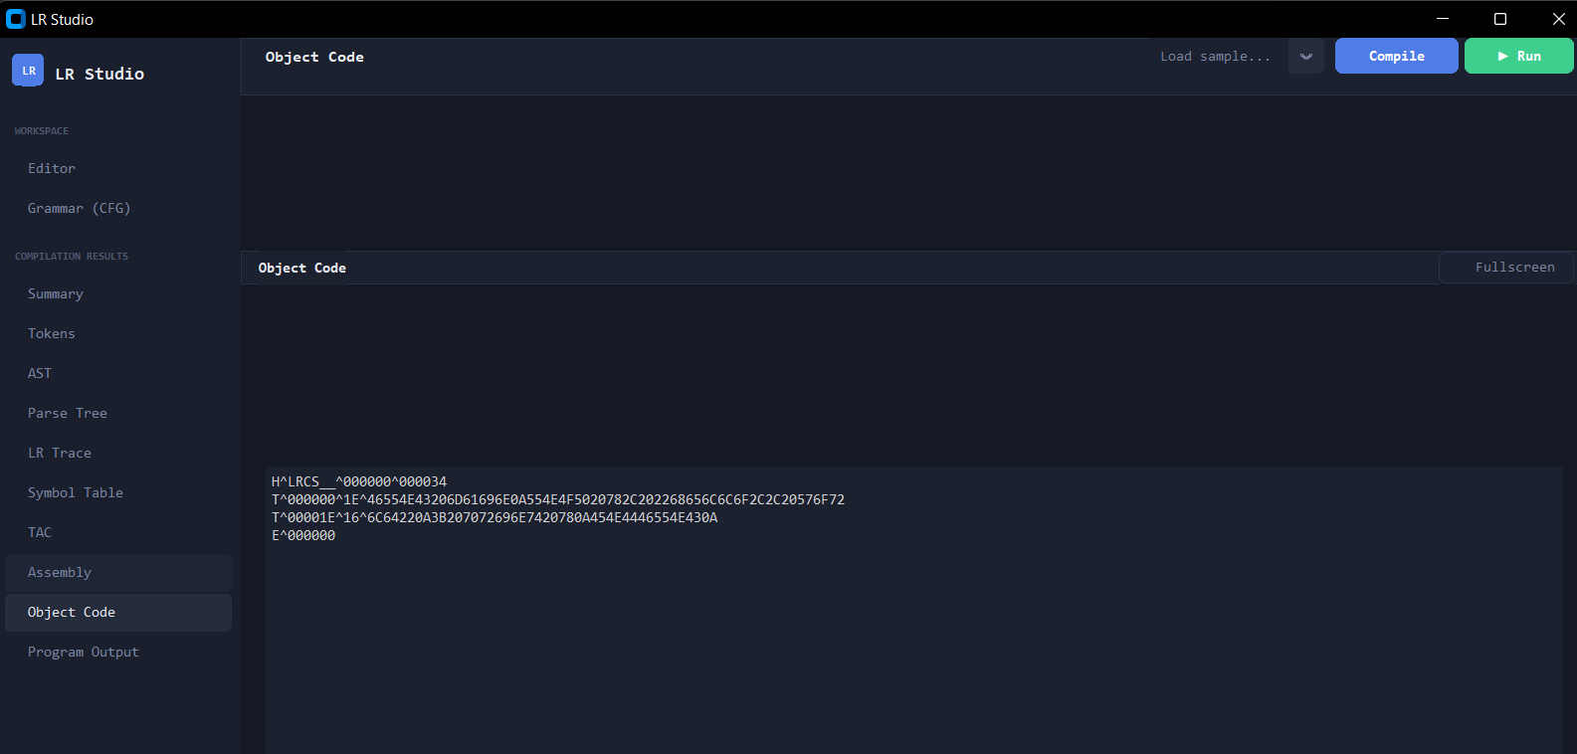

Error handling
In error handling, the compiler reads the error and uses its error handling. The compiler shows the error in a human friendly, and with suggestions for how to remove errors.
Here is an incorrect code that will show how the program detects and handlse errors.
Input (Code):
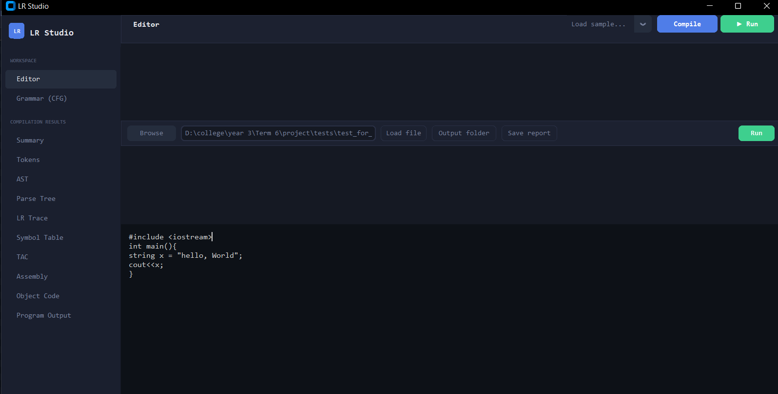
Output: 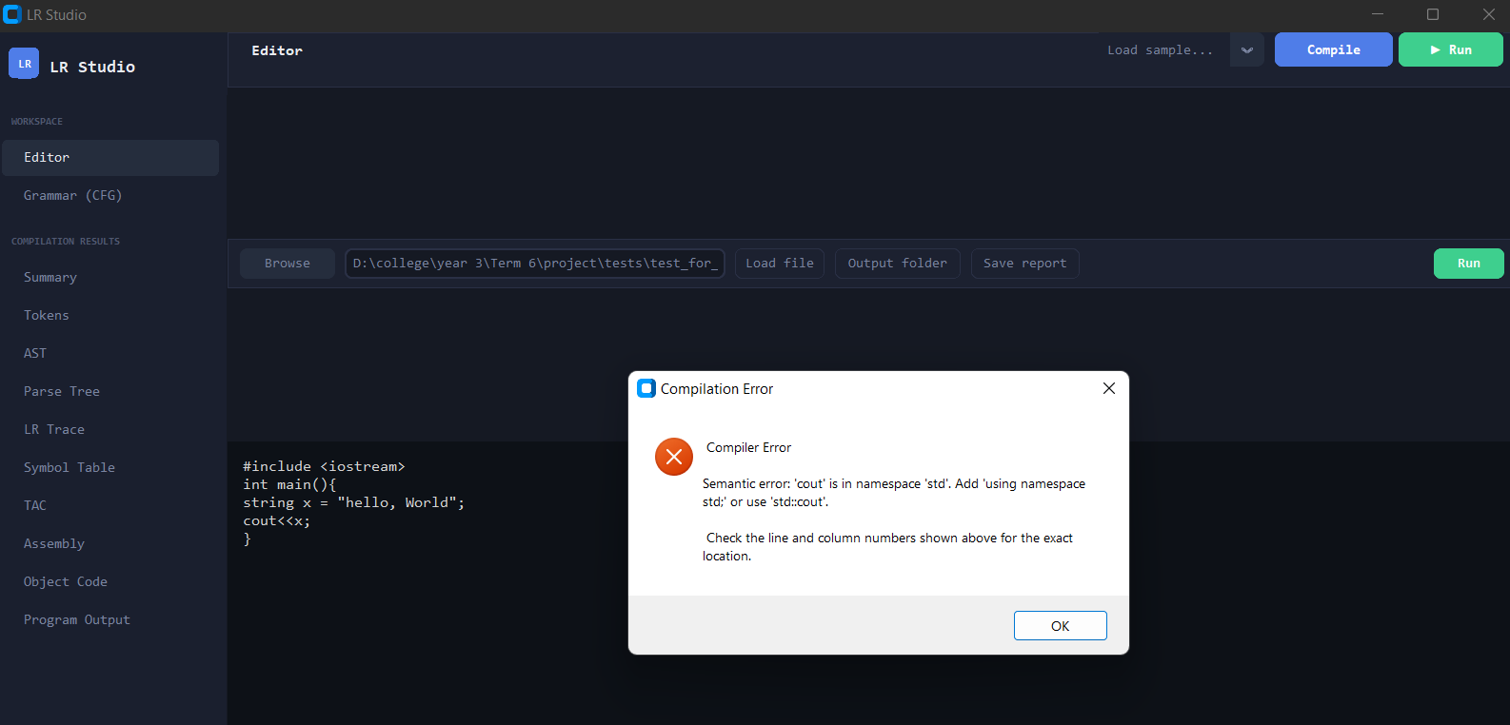

14. Conclusion
This project successfully demonstrates the complete implementation of a compiler pipeline for a C++ language subset, fulfilling all five required phases of the project. Starting from a formally defined Context-Free Grammar(CFG), the system processes source code through lexical analysis, LR(1) parsing, semantic analysis, and optimized three-address code generation: each phase implemented from scratch in Python without relying on any external compiler tools or parser generators.
The lexer accurately tokenizes all supported constructs including keywords, operators, literals, and comments, while providing precise error reporting. The LR(1) parser, built from automatically generated states, produces both an Abstract Syntax Tree and a concrete parse tree in JSON format, along with a full step-by-step parsing trace. The semantic analyzer enforces variable scoping, type compatibility, duplicate declaration detection, and symbol table management across all scope levels. The intermediate code generator produces clean Three-Address Code that is then refined through four optimization passes: constant folding, copy propagation, common subexpression elimination, and dead code elimination, before being translated into pseudo-assembly and encoded into an HTE object file.
Beyond the required phases, the project includes a fully functional tree-walking interpreter with an interactive terminal that streams output live and accepts cin input at runtime, supporting array-subscript targets such as cin >> arr[i], as well as a graphical IDE built with CustomTkinter that visualizes every compilation in both text and interactive tree form.
Through this project, we have gained practical experience in formal language theory, parsing algorithms, compiler design, and software engineering narrowing the gap between theoretical concepts and a fully working implementation.
This project, like any complex Software system, presents opportunities for further enhancement and refinement. Within the given timeframe, our team focused on delivering a complete, reliable, and well-structured solution. we successfully achieved all required objectives and delivered a comprehensive and functional system. The current implementation meets all specified requirements and serves as a strong basis for future improvements. We ensured that all compiler phases were working and fully satisfied project requirements, while maintaining a high standard of implementation. Future improvements can build upon this strong foundation.

15. terminologies
Term | Definition
AST | Abstract Syntax Tree: tree where each node represents a meaningful language construct. Redundant grammar structure is stripped away.
CFG | Context-Free Grammar: a formal grammar that defines language syntax through production rules.
Dangling Else | Ambiguity in grammars with optional else clauses; resolved here by splitting Stmt into MatchedStmt and UnmatchedStmt.
FIRST(A) | The set of terminals that can start a string derived from A.
FOLLOW(A) | The set of terminals that can immediately follow A in any sentential form.
GOTO Table | LR table: given current state and a non-terminal (after a reduce), returns the next parser state.
ACTION Table | LR table: given current state and a terminal (lookahead), returns shift/reduce/accept/error.
HTE | Simplified object file format, using H/T/E records.
IR | Intermediate Representation: a program form between the source and target. The project uses TAC.
LR(1) | Left-to-right scan, Rightmost derivation, 1 token of lookahead.
Lookahead | The next token in the input used to decide whether to shift or reduce.
Parse Tree | The concrete derivation tree showing every grammar symbol.
TAC | Three-Address Code: IR where each instruction has at most 3 operands:  result = operand1 op operand2.
Token | The smallest meaningful unit produced by the lexer: a (type, lexeme, line, column) tuple.
Tree-Walk Interpreter | An interpreter that executes a program by recursively traversing the AST, without compiling to any intermediate form first.

